**AnisoVis**

Visualising Anisotropy in Rock Forming Minerals

**User Guide**

Version 0.9, October 2019

David Healy

[d.healy@abdn.ac.uk](mailto:d.healy@abdn.ac.uk)



**Contents**

Introduction

Obtaining & Installing the code

Input files

Output formats

Theoretical basis for the calculations

Acknowledgements

References

**Introduction**

**AnisoVis** is a set of custom scripts linked to a graphical user interface (GUI), written in MATLAB™. **AnisoVis** is designed to visualise the directional variations in elastic, acoustic and optical properties of rock forming minerals. The source code is available as an open source project on GitHub and through the MathWorks™ FileExchange server (see below). Single mineral elasticity values are supplied as input data, together with lattice parameters defining the unit cell and symmetry. The code calculates the directional variations in elastic properties and produces outputs of the kinds shown in Figures N…. **AnisoVis** can also calculate the acoustic velocities (phase and group) and their polarisations, and the optical birefringence from the refractive indices. Over 240 data files for 86 different minerals are included (from published sources).

**AnisoVis** totals over 3,000 lines of code. As in any software project of this scale, there will be ‘bugs’ – i.e. my coding errors. If you encounter a bug, please let me know, through GitHub, Mathworks™ FileExchange or by e-mail ([d.healy@abdn.ac.uk](mailto:d.healy@abdn.ac.uk)). Please provide as many details as you can, including (where possible): a screen shot of the MATLAB error message, the input data file you were using at the time, the MATLAB™ version and your operating system platform.

**Obtaining and Installing the code**

You can get all the source code and run it directly from the MATLAB command window. The code and this User Guide are available on GitHub:

<https://github.com/DaveHealy-Aberdeen/AnisoVis>

and on the Mathworks FileExchange:

**AnisoVis** is installed by copying all of the files from the GitHub or Mathworks FileExchange server into a folder on the user’s computer. **AnisoVis** will run on any computer with MATLAB installed, including those running Microsoft Windows, Mac OS X or different flavours of Linux. After starting MATLAB, the working folder or directory should be set to the folder containing all of the installed source code. The application is started by typing ‘AnisoVis’ in the Command window of the MATLAB session. There is only one window in **AnisoVis** (Figure 1). Click Browse… to show the standard dialog to open an input file of mineral properties. These are stored in formatted tab-delimited ASCII text files with an extension of ‘.mdf2’ (‘mineral data file’). Examples are shown in Figure 2.

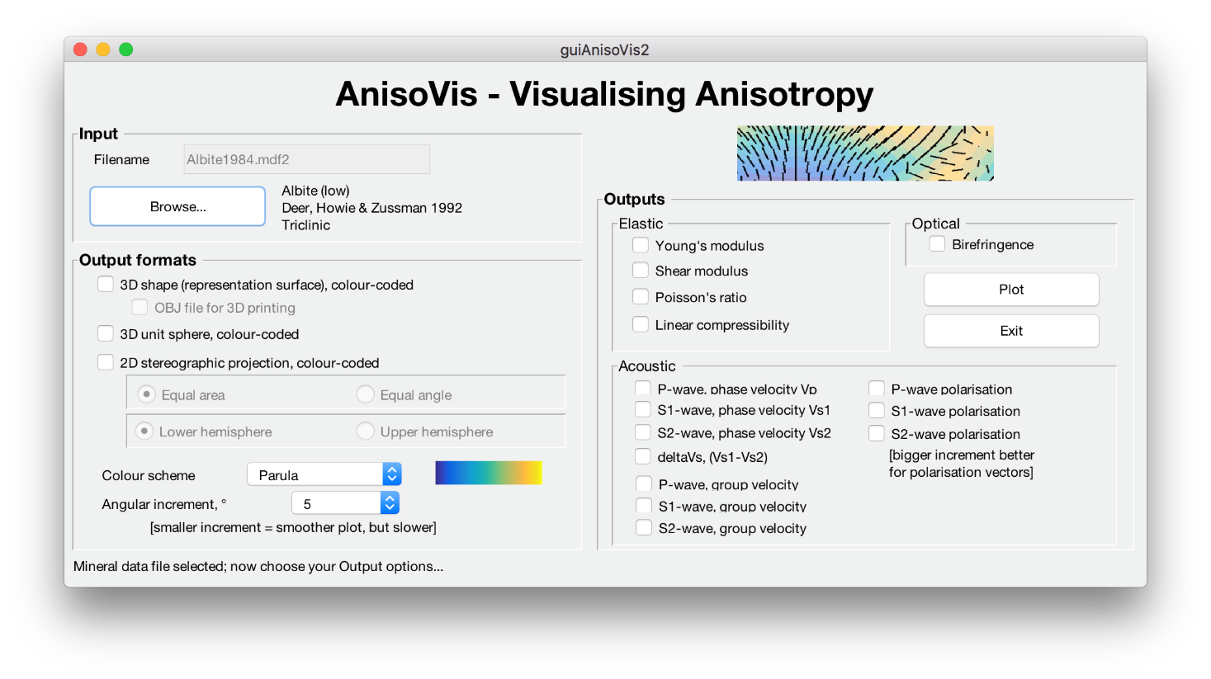

**Figure 1.** The main (and only window) in AnisoVis, here shown running on a Mac.

**Input files**

*.mdf format

examples

Click Browse… to select an input data file. The file types are filtered to those with an extension of ‘*.mdf2’ (‘mineral data file’).

**Output formats**

Output is directed to MATLAB figure windows, with one plotted property per figure window. These images are automatically saved as ‘.tif’ files at 600 dpi resolution in the working folder. While each figure window is visible, the user can exploit standard MATLAB functionality to resize or reformat the figure as they wish, and can save the figure to a different filename or folder, or even a different graphic format (e.g. ‘.png’ or ‘.jpeg’). The colour schemes used for the representation surfaces, unit spheres and stereograms can be varied using the drop-down list box in the main window. In addition to the standard MATLAB colour map of ‘Parula’ we offer 3 other choices from the cmocean colour map library (Thyng et al., 2016) using perceptually uniform scales (‘Haline’, ‘Thermal’ and ‘Matter’).

**Theoretical basis for the calculations**

*Elasticity*

See the paper on EarthArXiv

*Visualising elastic anisotropy in 2-D and 3-D*

As pointed out by Nye (1985), no single surface can represent the elastic behaviour of a crystal completely. However, we can plot specific surfaces that are useful in practice. To visualise the anisotropy of elastic properties of single crystals we use a mixture of 3D surfaces and 2D polar plots projected onto selected planes. We use representation surfaces (Nye, 1985) to generate 3D shapes where, for any given radius vector measured from the origin to the surface, the radius is proportional to the magnitude of the property in that direction. The magnitude of the property is also conveyed by a colour mapping applied to the surface. An alternative method is to plot the directional variation of a property projected onto a unit sphere, using a colour map to depict the magnitude. We can also use stereographic projections (lower hemisphere, equal area) to show directional variations in properties. Lastly, we can use polar plots to the variation of a property in selected crystallographic planes (e.g. [100], [010], [001]).

*Challenges in visualising Poisson’s ratio ( and shear modulus G*

Any of the above methods of visualisation can be used for ‘simple’ elastic properties, such as Young’s modulus or linear compressibility, where the property is a single scalar value for a given direction. Young’s modulus is defined as the ratio of uniaxial stress to uniaxial strain and it is implicit that the directions of applied stress and measured strain are coincident (i.e. coaxial). However, for Poisson’s ratio and shear modulus this is no longer the case. Poisson’s ratio is defined as the ratio of (negative) lateral strain to the axial strain, and therefore involves two orthogonal directions. Shear modulus is defined as the ratio of the shear stress to the shear strain, again involving two orthogonal directions (see Figure N). For a stress (normal or shear) applied in a specific direction, there is only one value of E, but there are many possible values of  and G. It can be seen from Figure N that  and G will vary according to the direction of the normal to the chosen direction, described by angle  in the Turley & Sines (1971) notation. To plot representation surfaces for  and G, we take their minimum and maximum values calculated over  for an applied stress along each direction in 3-space. In addition, as  can be negative for some directions in some minerals, we further separate the minimum representation surfaces of Poisson’s ratio into negative minimum and positive minimum components where appropriate.

*Acoustic velocities*

The velocity of acoustic waves passing through rocks and minerals is a direct function of their elastic properties and their density, expressed through the Christoffel equation (Zhou & Greenhalgh, 2004).

*Optical anisotropy (birefringence)*

The calculation of the optical birefringence for a given mineral is based on the method by Sorensen (2012), with equations from standard texts by Bloss (1961) and Johannsen (1918). We first produce the Michel-Levy interference colour chart, and then work out the retardation for each direction in the crystal based on the supplied refractive indices and the mineral symmetry. The colour for each direction is then a simple look-up into the Michel-Levy table. Full details of the method, including the mapping of the theoretical spectral colours to actual human vision colours using the CIE colour matching functions, can be found in Sorensen (2012). The relevant code is in scripts guiPlotMichelLevy.m and guiPlotAniso.m.

**Acknowledgements**

I have used the following public domain MATLAB code in AnisoVis:

* cmocean colour maps (Thyng et al., 2016)
* various routines from Allmendinger et al. (2011, Structural geology algorithms: Vectors and tensors)

**References**

Allmendinger, R.W., Cardozo, N. and Fisher, D.M., 2011. Structural geology algorithms: Vectors and tensors. Cambridge University Press.

Almqvist, B.S. & Mainprice, D., 2017. Seismic properties and anisotropy of the continental crust: predictions based on mineral texture and rock microstructure. Reviews of Geophysics, 55(2), pp.367-433.

Bloss, F.D., 1961. *An introduction to the methods of optical crystallography*. Holt, Rinehart & Winston.

Britton, T.B., Jiang, J., Guo, Y., Vilalta-Clemente, A., Wallis, D., Hansen, L.N., Winkelmann, A. and Wilkinson, A.J., 2016. Tutorial: Crystal orientations and EBSD—Or which way is up?. Materials Characterization, 117, pp.113-126.

Guo, C.Y. & Wheeler, L., 2006. Extreme Poisson's ratios and related elastic crystal properties. Journal of the Mechanics and Physics of Solids, 54(4), pp.690-707.

**Healy, D.**, Timms, N.E. & Pearce, M. (in review). The variation and visualisation of elastic anisotropy in rock forming minerals.

Johannsen, A., 1918. *Manual of petrographic methods.* McGraw-Hill Book Company, Incorporated.

Musgrave, M.J., 1970. Crystal acoustics: introduction to the study of elastic waves and vibrations in crystals.

Nye, J.F., 1957. *Physical Properties of Crystals*. Clarendon Press.

Sørensen, B.E., 2012. A revised Michel-Lévy interference colour chart based on first-principles calculations. European Journal of Mineralogy, 25(1), pp.5-10.

Thyng, K. M., Greene, C. A., Hetland, R. D., Zimmerle, H. M., & DiMarco, S. F. 2016. True Colors of Oceanography. Oceanography, 29(3), 10.

Turley, J. & Sines, G., 1971. The anisotropy of Young's modulus, shear modulus and Poisson's ratio in cubic materials. Journal of Physics D: Applied Physics, 4(2), p.264.

Zhou, B. and Greenhalgh, S., 2004. On the computation of elastic wave group velocities for a general anisotropic medium. Journal of Geophysics and Engineering, 1(3), pp.205-215.